Bayside Farmer’s Market 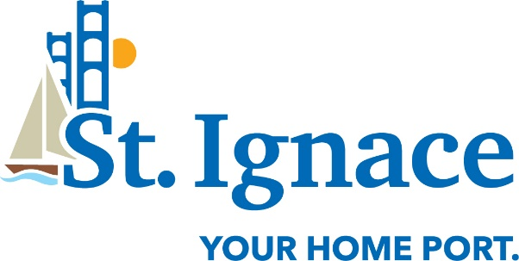
St. Ignace Marina Lawn
Downtown St. Ignace
July 7 – September 29 (excluding September 15)
2022 Application
If you plan to participate in the Bayside Farmer’s Market, even on an occasional basis, you must complete the application, sign the form, and return it to 6 Spring St., St. Ignace, MI 49781, email it to quincy@stignace.com, or submit the completed form to the Event Host at the market. You also agree to abide by all market rules (listed separately).
Vendor Name:
Primary Contact Person:
Address:
City/State/Zip:
Email Address:
Telephone:

Products to be sold:
1.
2.
3.
4.

Signature: Date:

